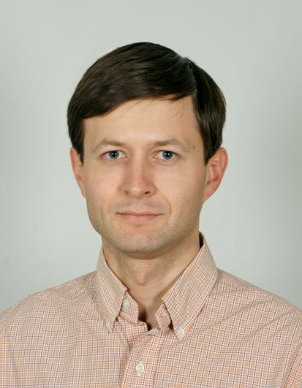
23.08.1982 Phone: +3 8 063 320 79 21
Lviv, E-mail: avinogradov.lvov@gmail.com
Ukraine Skype: sas123sas123
www.facebook.com/alex.alex.747

Alexander Vinogradov

Summary:
- Highly motivated to continue improving myself in IT as a junior/trainee Java developer.
- Was a PM on one of the VR projects. Can act as the PM on the mobile and VR projects.
- Currently studying basics of Java programming by G.Schildt.
- 2 years experience as IT Business Development manager. First 7000$ sale after 2 months after start.
- 6 years experience as a Area Sales Manager in pharmbusiness. Provide sales increasing, employee coaching, sales forecasting, invention and implementation of new advertising strategies, employee management.

Experience:
- 01.09.16 – 01.02.17 – Client Partner at Relevant Software – eHealth & VR areas.
- engaged 4 large projects (100K$-1M$) to the stage of negotiations and proposal presentation.
- acquired 1 partner from Amsterdam, CEO of digital agency, who outsources work to Relevant.
- requirements specification and optimal set of technologies for new eHealth and VR customers. On this basis, preparation of the proposal assessment and approach to the project presentation via Skype.

- 01.02.16 – 01.09.16 – BDM at ThinkMobiles (Uzhgorod) – Mobile & VR/AR dev.
- started planned campaign of acquiring, assessing & processing a LinkedIn leads in the VR and eHealth areas to a longtime partnerships.
- Responsible for training of 3 junior internet researchers.
- was a PM on one of the VR projects. Can act as the PM on the mobile and VR projects.

- 01.10.14 – 01.02.16 – Business Development with SECL Group – web digital agency.
- registered the Company profiles on Upwork, Guru, Freelancer boards. Started acquiring clients from this channel after 2 months from starting.
- I worked with on-site leads, with LinkedIn leads and constantly in search of new sales channels.
- also responsible for DIGITOV business-school. Students recruitment and payment process.
- I understand that one of the biggest channels of sales in the IT is the Networking. Attended the Outsource People 2015 and LIOF 2016 and a number of smaller events. Made a lot of useful connections and friends there. Keeping acquiring quality leads from this channel.

- 01.02.07 – 31.12.13 – Area Sales Manager (Rx) West (8 regions, 10 subordinates) “Farmaceutical firm ”Darnitsa” (cardiology, gastroenterology, antibiotics).
- staffing, and team building from scratch
- training, coaching, motivation (incl. intangible). Audit of Medical Representatives work.
- sales planning, budget planing, promoactons planning, routes of MR planning.

Foreign languages

- Russian and Ukrainian (excellent), Polish (very good), English (C1, pre-advanced)

- A high level of stressdealing and emotional intelligence.
- Working with computer-experienced user (all kinds of CRM/ERP systems)

Interests:

- Business analytics, football every week, mountaineering, cars

Recommendations will be presented on request.

